Review userstory Agent-UI
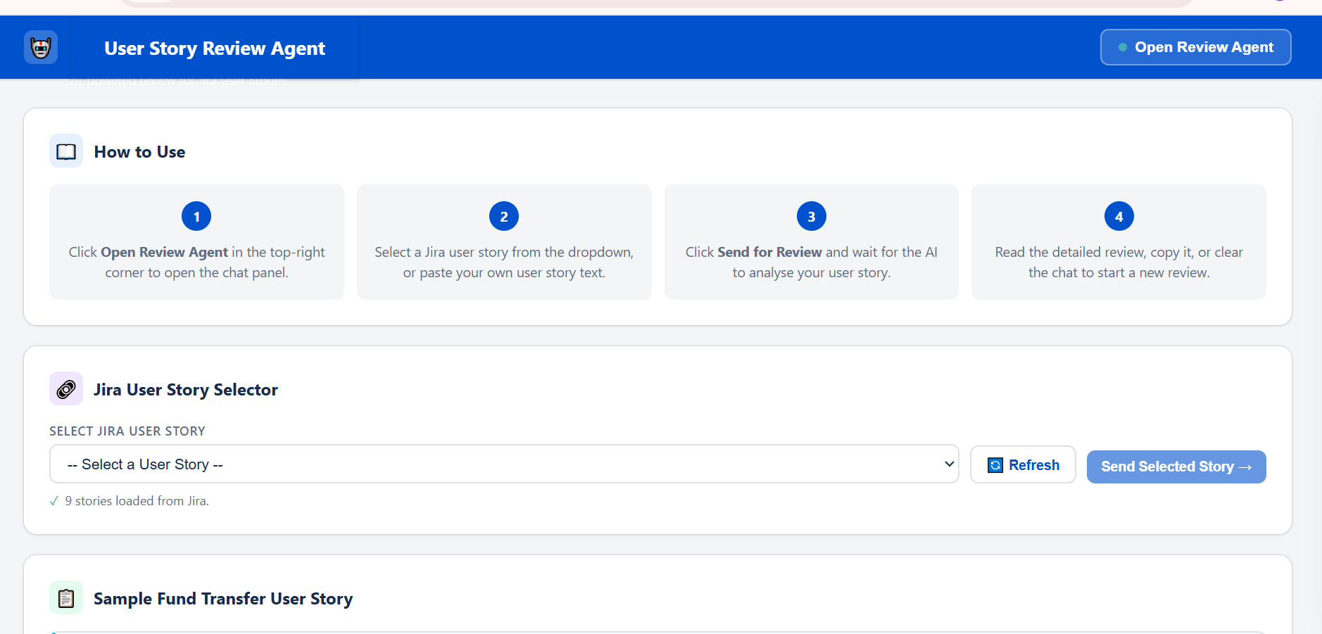

Select from the list of userstories from Jira in below drop down list
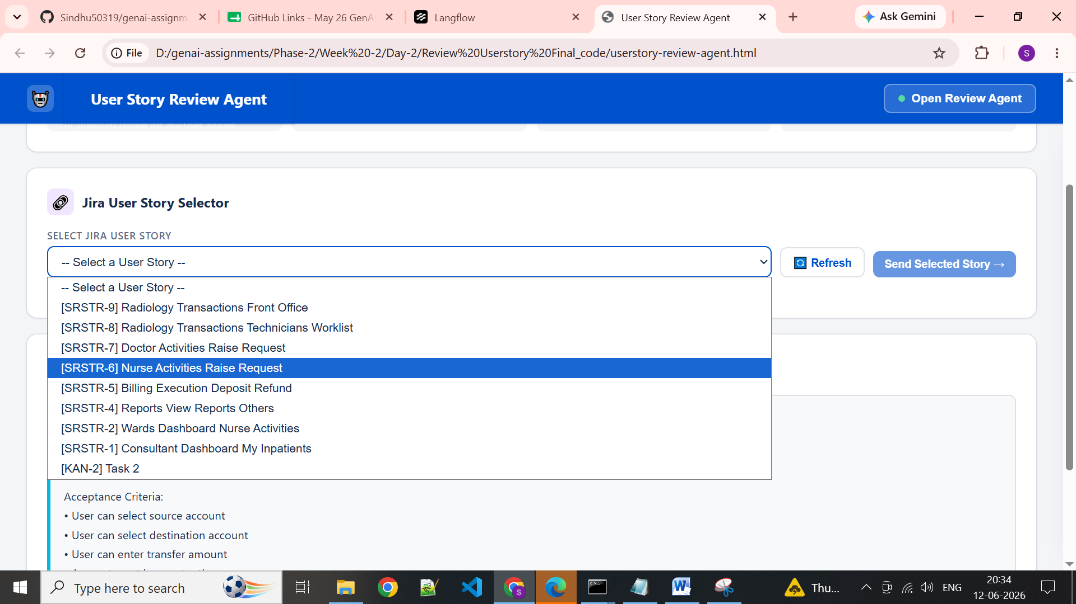

Click on send select story
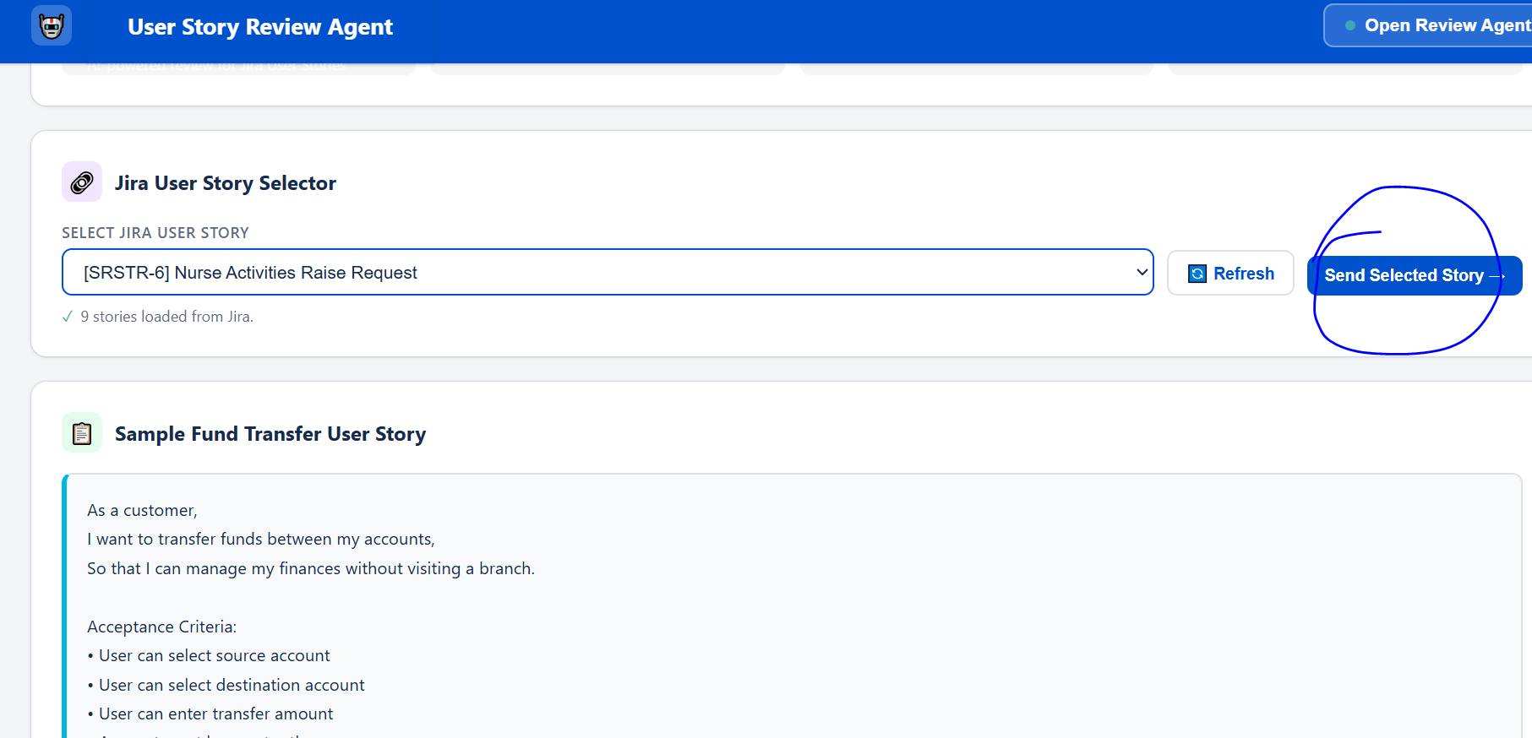

Story selected and added to chat agent for review-
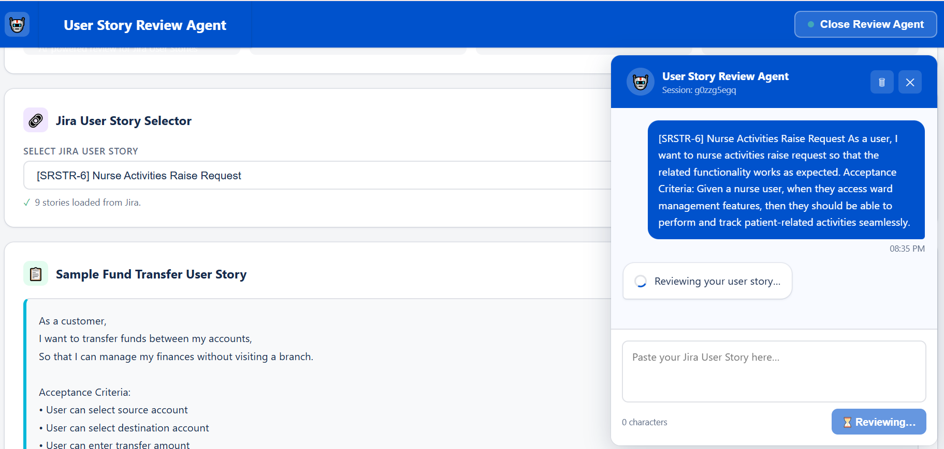

Output:
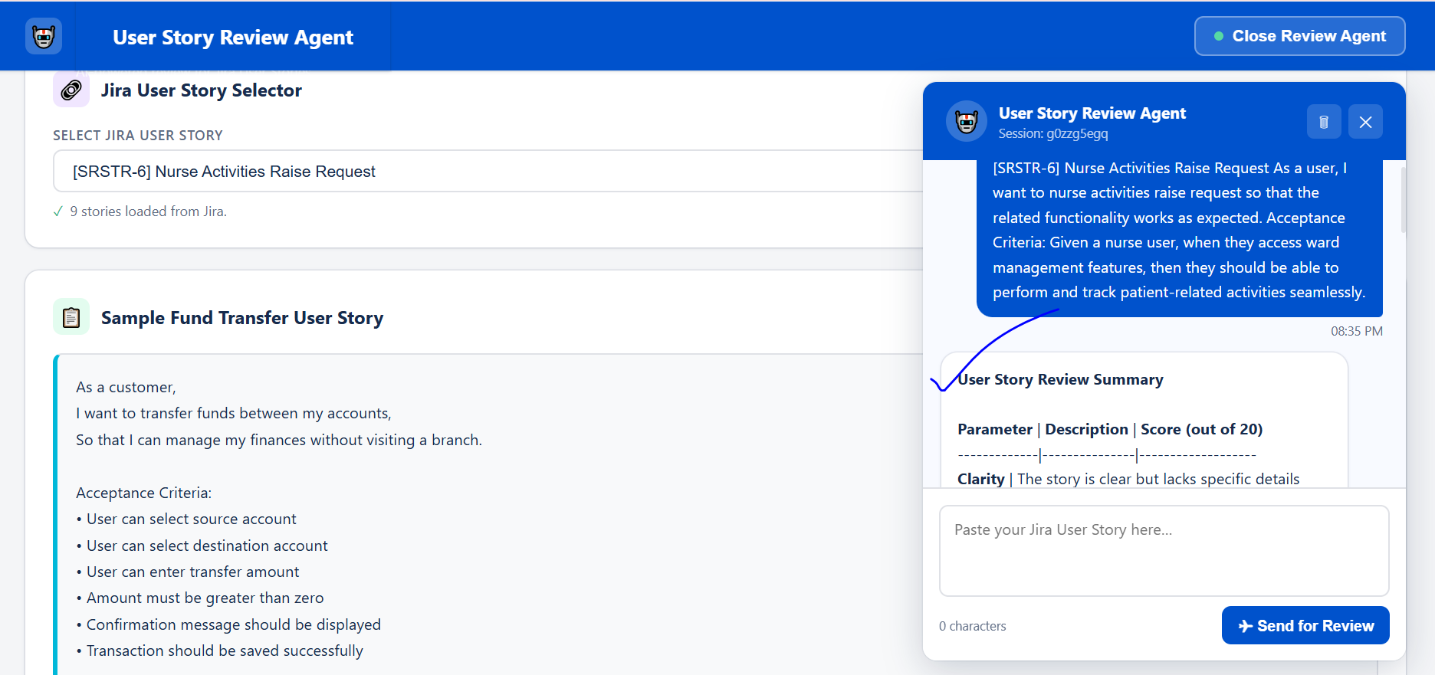

Output:
User Story Review Summary

Parameter | Description | Score (out of 20)
-------------|---------------|-------------------
Clarity | The story is clear but lacks specific details about the intended action. | 18
Completeness | Preconditions are mentioned but acceptance criteria could be more detailed. | 16
Business Value Alignment | The story has moderate relevance to healthcare, but could be more specific about the value added. | 15
Testability | Can be tested through system functionality validation. | 19
Technical Feasibility | Technically feasible with existing system infrastructure. | 17

Overall Score: 85 / 100

Improvement Areas:

1. Add specific details about the intended action: Clarify what action the user wants to perform on the worklist.
2. Enhance acceptance criteria: Specify what constitutes "functional expectations" and how the system will meet them.
3. Emphasize business value: Explain how this feature will improve radiology transactions or patient care.
4. Consider system actor details: Identify who will be using the worklist and how they will interact with the system.

Recommendations for Improvement:

* Consider adding a user persona to help clarify the intended user and their goals.
* Break down the acceptance criteria into smaller, more manageable tasks to ensure clear understanding and testing.
* Review the system's existing infrastructure to ensure that the new feature aligns with existing technical capabilities.

Action Items:

* Review and revise the user story to incorporate the recommended improvements.
* Collaborate with the development team to ensure that the new feature meets the acceptance criteria and is technically feasible.
* Schedule a follow-up review to ensure that the improvements have been implemented and the user story meets the required quality standards.

